**Experiment-04**

**--------------------------------------------------------------------**

**Name:** Atharva Paliwal

**Roll No.:** 40

**Date:** 12-09-2021

**--------------------------------------------------------------------**

**Aim:** To perform web scrapping and then perform analysis.

(A) Extract paragraph data from Wikipedia along with image and display image and text extracted.

(B) Extract whether data from the given URL and perform various analytic tasks like find average temperature.

(C) Extract images based on category and save in separate folders that can be used as training images for machine learning algorithm.

**Theory:**

Web Scrapping Web scraping (also called web data extraction or data scraping) provides a solution for those who want to get access to structured web data in an automated fashion. Web scraping is useful if the public website you want to get data from doesn’t have an API, or it does but provides only limited access to the data.

Steps to perform web scrapping

Step-1: Provide Url and download the web page using requests library Requests (HTTP) Library for Web Scraping – It is used for making various types of HTTP requests like GET, POST, etc. It is the most basic yet the most essential of all libraries.

* Requests allows you to send HTTP requests
* It enables downloading pages using the Python requests library. The requests library will make a GET request to a web server, which will download the HTML contents of a given web page for us.
* Download page using requests.get() method.
* After running our request, we get a Response object. This object has a status_code property, which indicates if the page was downloaded successfully.
* And a content property that gives the HTML content of the webpage as output.

Step 2: Beautiful Soup for page parsing

Beautiful Soup Library for Web Scraping – Its work involves creating a parse tree for parsing content. A perfect starting library for beginners and very easy to work with.

* After the contents of the page are downloaded, BeautifulSoup a Python library is used for pulling data out of HTML and XML files.
* It needs an input (document or URL) to create a soup object as it cannot fetch a web page by itself.
* We have other modules such as regular expression, lxml for the same purpose.
* We then process the data in CSV or JSON or MySQL format.
* As all the tags are nested, we can move through the structure one level at a time. We can first select all the elements at the top level of the page using the children property of soup.
* Note that children returns a list generator, so we need to call the list function on it:
* If we want to extract a single tag, we can instead use the find_all() method, which will find all the instances of a tag on a page. Note that find_all() returns a list, so we’ll have to loop through, or use list indexing, to extract text. If you instead only want to find the first instance of a tag, you can use the find method, which will return a single BeautifulSoup object.

**Code and Output**

**Part A:**

In

[1]:

**!**

pip

install

selenium

**!**

pip

install

requests

**!**

pip

install

urllib3

**!**

pip

install

bs4

1

2

3

4

Requirement already satisfied: selenium in d:\anaconda\lib\site-packages (3. 141.0)

Requirement already satisfied: urllib3 in d:\anaconda\lib\site-packages (fro m selenium) (1.25.11)

Requirement already satisfied: requests in d:\anaconda\lib\site-packages (2.

24.0)

Requirement already satisfied: urllib3!=1.25.0,!=1.25.1,<1.26,>=1.21.1 in d:\anaconda\lib\site-packages (from requests) (1.25.11)

Requirement already satisfied: idna<3,>=2.5 in d:\anaconda\lib\site-packages (from requests) (2.10)

Requirement already satisfied: certifi>=2017.4.17 in d:\anaconda\lib\site-pa ckages (from requests) (2020.6.20)

Requirement already satisfied: chardet<4,>=3.0.2 in d:\anaconda\lib\site-pac kages (from requests) (3.0.4)

Requirement already satisfied: urllib3 in d:\anaconda\lib\site-packages (1.2 5.11)

Requirement already satisfied: bs4 in d:\anaconda\lib\site-packages (0.0.1) Requirement already satisfied: beautifulsoup4 in d:\anaconda\lib\site-packag es (from bs4) (4.9.3)

Requirement already satisfied: soupsieve>1.2; python_version >= "3.0" in d:\anaconda\lib\site-packages (from beautifulsoup4->bs4) (2.0.1)

[2]:

*# import required modules*

**import**

requests

*# get URL*

page

**=**

requests

.

get

(

"https://en.wikipedia.org/wiki/Paragraph"

)

*# display status code*

print

(

page

.

status_code

)

*# display scrapped data*

print

(

page

.

content

)

1

2

3

4

5

6

7

8

9

10

11

200

b'<!DOCTYPE html>\n<html class="client-nojs" lang="en" dir="ltr">\n<head> \n<meta charset="UTF-8"/>\n<title>Paragraph - Wikipedia</title>\n<script> document.documentElement.className="client-js";RLCONF={"wgBreakFrames":! 1,"wgSeparatorTransformTable":["",""],"wgDigitTransformTable":["",""],"wg

DefaultDateFormat":"dmy","wgMonthNames":["","January","February","Marc h","April","May","June","July","August","September","October","Novembe r","December"],"wgRequestId":"88b2811d-7640-4718-97d3-5fdcf9cd644e","wgCS PNonce":!1,"wgCanonicalNamespace":"","wgCanonicalSpecialPageName":!1,"wgN amespaceNumber":0,"wgPageName":"Paragraph","wgTitle":"Paragraph","wgCurRe visionId":1039583963,"wgRevisionId":1039583963,"wgArticleId":230752,"wgIs Article":!0,"wgIsRedirect":!1,"wgAction":"view","wgUserName":null,"wgUser Groups":["*"],"wgCategories":["Articles with limited geographic scope fro m June 2013","Articles containing Ancient Greek (to 1453)-language tex t","All articles with unsourced statements","Articles with unsourced stat ements from January 2020","Typography","Writing"],"wgPageContentLanguag e":"en","wgPageContentModel":"wikitext",\n"wgRelevantPageName":"Paragrap h","wgRelevantArticleId":230752,"wgIsProbablyEditable":!0,"wgRelevantPage IsProbablyEditable":!0,"wgRestrictionEdit":[],"wgRestrictionMove":[],"wgF

l dR P " {"t " {" t t " {"l l " 1}}} " M di Vi O Cli

[3]:

*# import required modules*

**from**

bs4

**import**

BeautifulSoup

*# scrape webpage*

soup

**=**

BeautifulSoup

(

page

.

content

,

'html.parser'

)

*# display scrapped data*

print

(

soup

.

prettify

())

1

2

3

4

5

6

7

8

<!DOCTYPE html>

<html class="client-nojs" dir="ltr" lang="en">

<head>

<meta charset="utf-8"/>

<title>

Paragraph - Wikipedia

</title> <script>

document.documentElement.className="client-js";RLCONF={"wgBreakFrame s":!1,"wgSeparatorTransformTable":["",""],"wgDigitTransformTable":

["",""],"wgDefaultDateFormat":"dmy","wgMonthNames":["","January","Februar y","March","April","May","June","July","August","September","October","No vember","December"],"wgRequestId":"88b2811d-7640-4718-97d3-5fdcf9cd644 e","wgCSPNonce":!1,"wgCanonicalNamespace":"","wgCanonicalSpecialPageNam e":!1,"wgNamespaceNumber":0,"wgPageName":"Paragraph","wgTitle":"Paragrap h","wgCurRevisionId":1039583963,"wgRevisionId":1039583963,"wgArticleId":2 30752,"wgIsArticle":!0,"wgIsRedirect":!1,"wgAction":"view","wgUserName":n ull,"wgUserGroups":["*"],"wgCategories":["Articles with limited geographi c scope from June 2013","Articles containing Ancient Greek (to 1453)-lang t t" "All ti l ith d t t t " "A ti l ith

[4]:

*# EXTRACTING PARAGRAPH*

list

(

soup

.

children

)

*# find all occurance of p in HTML*

*# includes HTML tags*

*# Why p? Because we want paragraphs*

print

(

soup

.

find_all

(

'p'

))

print

(

'\n\n'

)

print

(

"================================================================================

*# return only text*

*# does not include HTML tags*

print

(

soup

.

find_all

(

'p'

)[

0

].

get_text

())

print

(

"================================================================================

1

2

3

4

5

6

7

8

9

10

11

12

13

14

15

[<p>A <b>paragraph</b> (from the <a href="/wiki/Ancient_Greek" title="Anc ient Greek">Ancient Greek</a> <span lang="grc" title="Ancient Greek (to 1 453)-language text">παράγραφος</span>, <i lang="grc-Latn" title="Ancient Greek (to 1453)-language text">parágraphos</i>, "<i>to write beside</i>") is a self-contained unit of discourse in <a href="/wiki/Writing" title="W riting">writing</a> dealing with a particular point or <a href="/wiki/Ide a" title="Idea">idea</a>. A paragraph consists of one or more <a href="/w iki/Sentence_(linguistics)" title="Sentence (linguistics)">sentences</a>. <sup class="reference" id="cite_ref-UNC_1-0"><a href="#cite_note-UNC-1">

[1]</a></sup> Though not required by the syntax of any language, paragrap hs are usually an expected part of formal writing, used to organize longe r <a href="/wiki/Prose" title="Prose">prose</a>.<sup class="noprint Inlin e-Template Template-Fact" style="white-space:nowrap;">[<i><a href="/wiki/ Wikipedia:Citation_needed" title="Wikipedia:Citation needed"><span title

="This claim needs references to reliable sources. (January 2020)">citati on needed</span></a></i>]</sup>

</p>, <p>The oldest classical Greek and Latin writing had little or no sp ace between words and could be written in <a href="/wiki/Boustrophedon" t itle="Boustrophedon">boustrophedon</a> (alternating directions). Over tim t t di ti (l ft t i ht) b t d di d d < h f "/ ik

In

[5]:

>

span class="anchor" id="Decimal_numbering"

<

>

/span

<

*# EXTRACTING CUSTOMIZED TAG CONTENTS*

object

**=**

soup

.

find

(

id

**=**

"Numbering"

)

*# find tags*

items

**=**

object

.

find_all

(

class_

**=**

"anchor"

)

result

**=**

items

[

0

]

*# display tags*

print

(

result

.

prettify

())

1

2

3

4

5

6

7

8

9

10

[6]:

*# EXTRACTING IMAGE*

image_tags

**=**

soup

.

findAll

(

'img'

)

*# print out image urls*

**for**

image_tag

**in**

image_tags

:

print

(

image_tag

.

get

(

'src'

))

1

2

3

4

5

6

//upload.wikimedia.org/wikipedia/commons/thumb/b/bd/Ambox_globe_content.svg/

48px-Ambox_globe_content.svg.png

//upload.wikimedia.org/wikipedia/commons/thumb/5/59/United_States_Constituti on.jpg/220px-United_States_Constitution.jpg

//upload.wikimedia.org/wikipedia/commons/thumb/9/99/Wiktionary-logo-en-v2.sv g/16px-Wiktionary-logo-en-v2.svg.png

//upload.wikimedia.org/wikipedia/en/thumb/9/96/Symbol_category_class.svg/16p x-Symbol_category_class.svg.png

//en.wikipedia.org/wiki/Special:CentralAutoLogin/start?type=1x1

/static/images/footer/wikimedia-button.png

/static/images/footer/poweredby_mediawiki_88x31.png In [7]:

**from**

PIL

**import**

Image

*#read the image*

im

**=**

Image

.

open

(

"image1.jpg"

)

*#show image*

im

.

show

()

1

2

3

4

5

6

7

*#getting jpg images*

**import**

re

image_tags

**=**

soup

.

findAll

(

'img'

, {

'src'

:

re

.

compile

(

'.jpg'

)})

*# print out image urls*

**for**

image_tag

**in**

image_tags

:

print

(

image_tag

[

'src'

]

**+**

'\n'

)

1

2

3

4

5

6

//upload.wikimedia.org/wikipedia/commons/thumb/5/59/United_States_Constituti on.jpg/220px-United_States_Constitution.jpg

In

[8]:

**import**

urllib

.

request

urllib

.

request

.

urlretrieve

(

"https://upload.wikimedia.org/wikipedia/commons/thumb/5/59/U

1

2

Out[8]: ('image1.jpg', <http.client.HTTPMessage at 0x18abef144f0>)

In [9]:

In [ ]:

[10]:

Paragraph - Wikipedia

*# EXTRACTING TITLE*

title

**=**

soup

.

find_all

(

'title'

)

print

(

title

[

0

].

get_text

())

1

2

3

1

**Image Extracted:**

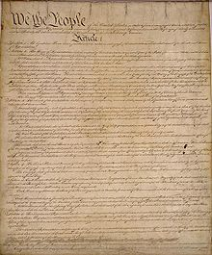

**Part B:**

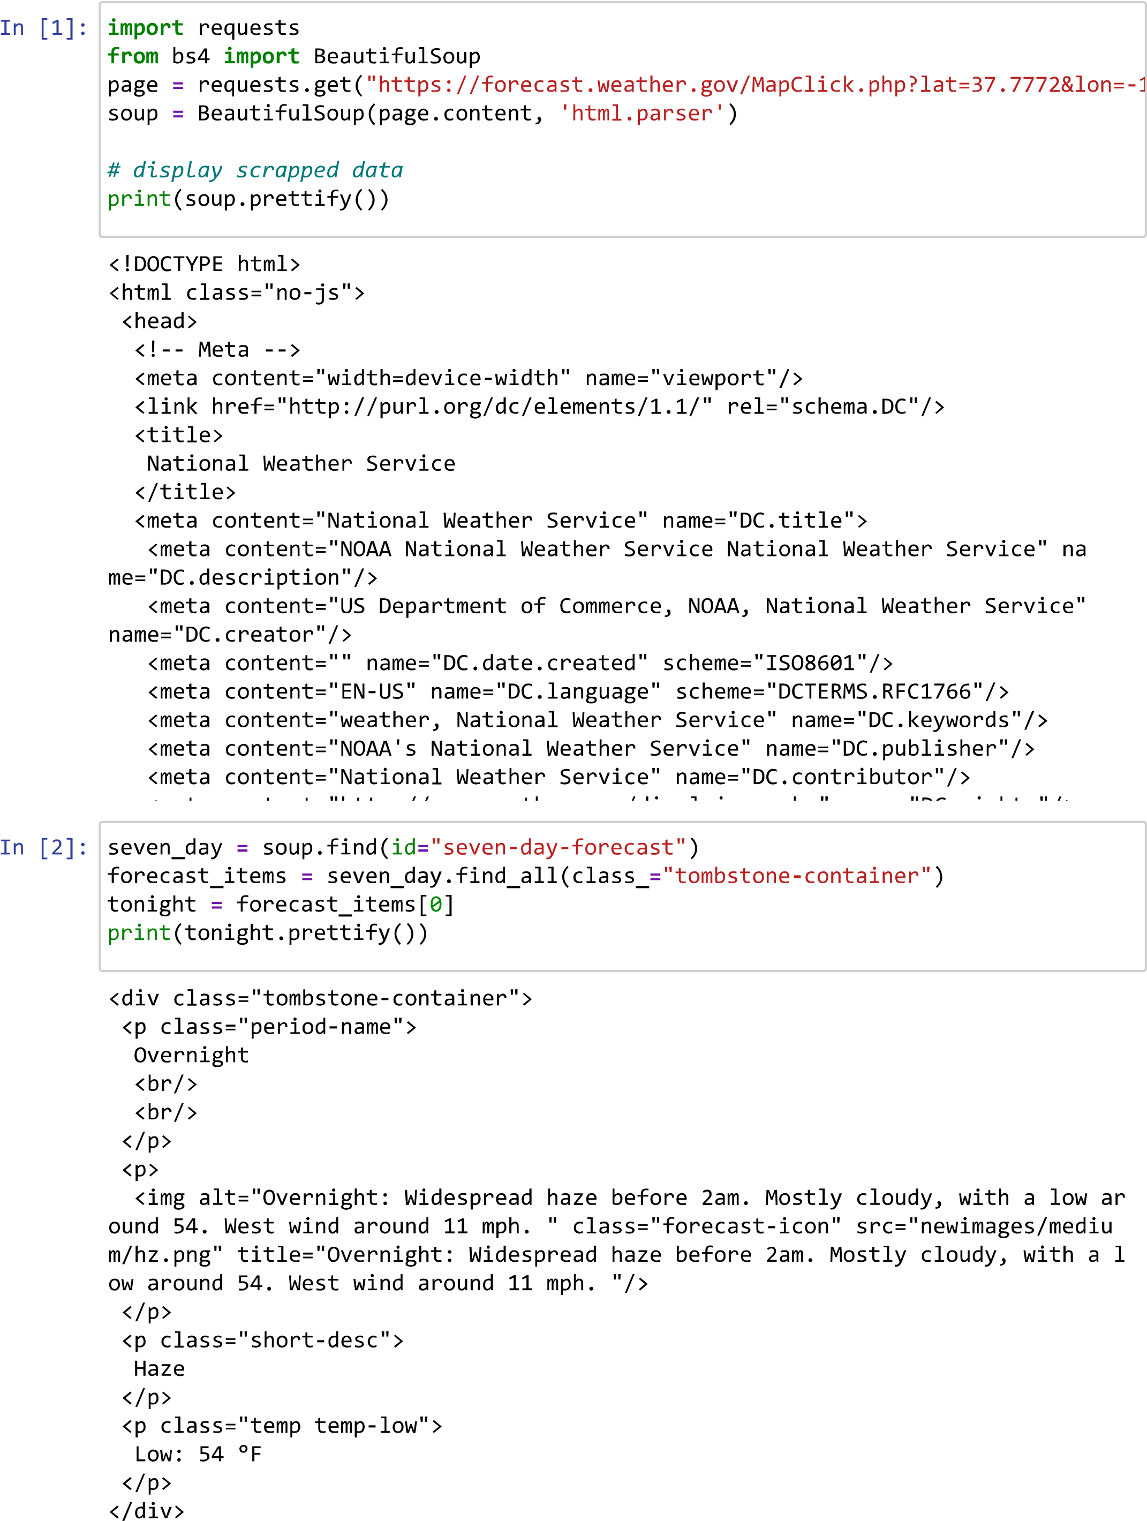

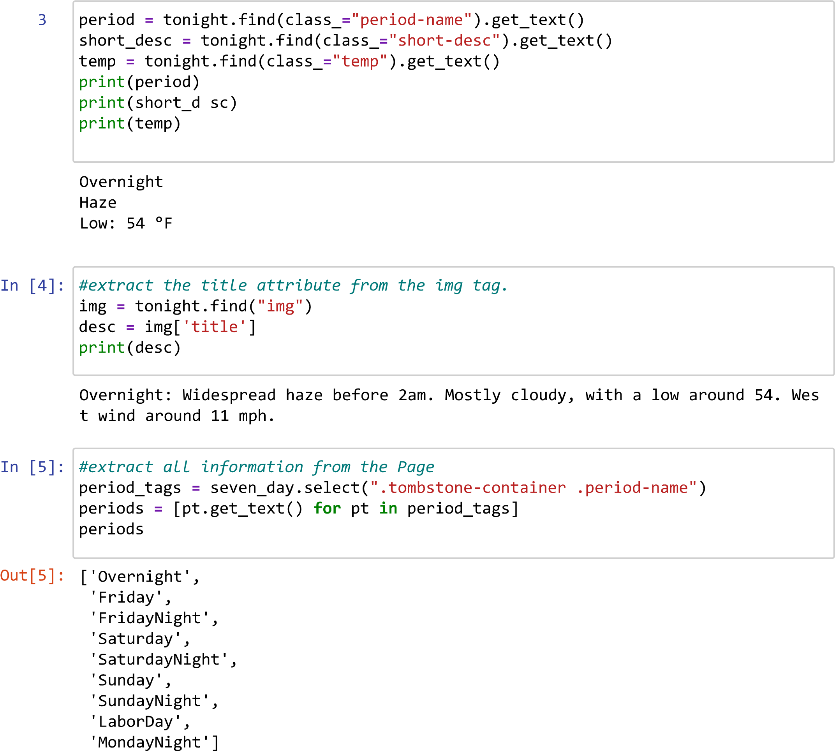

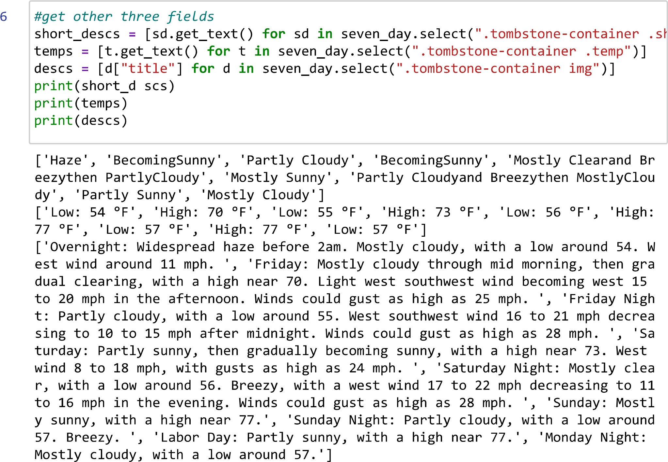

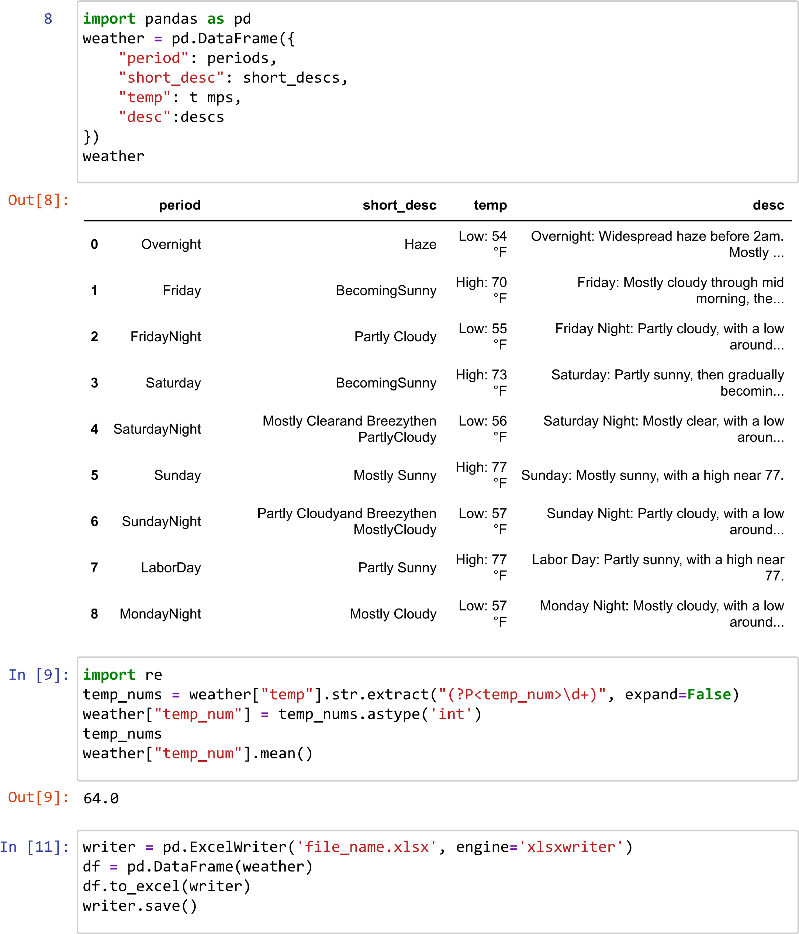

**Data Extracted:**

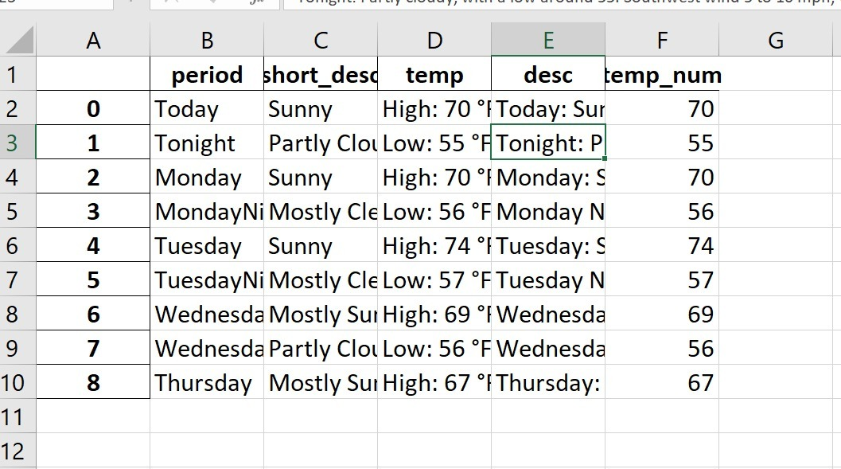

**Part C:**

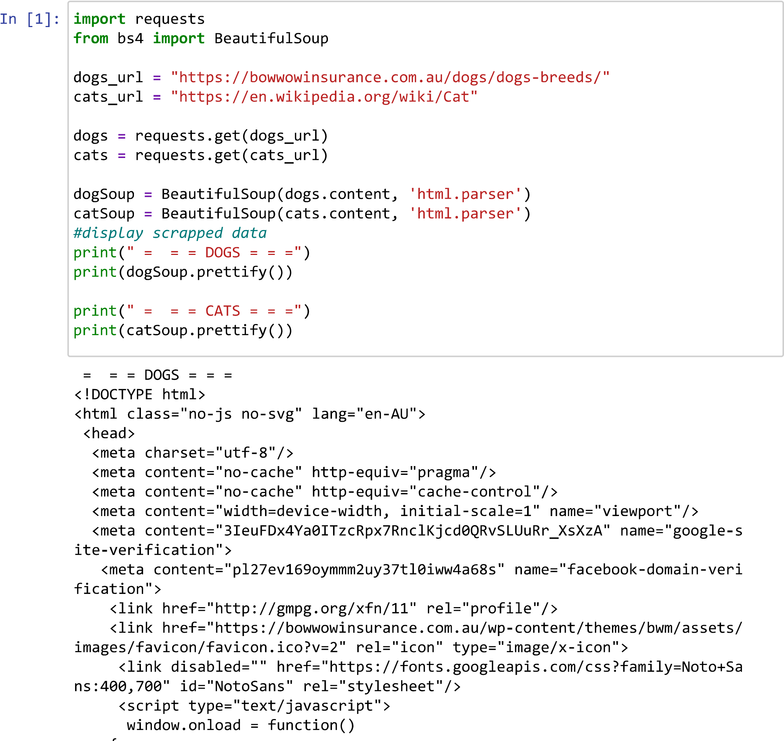

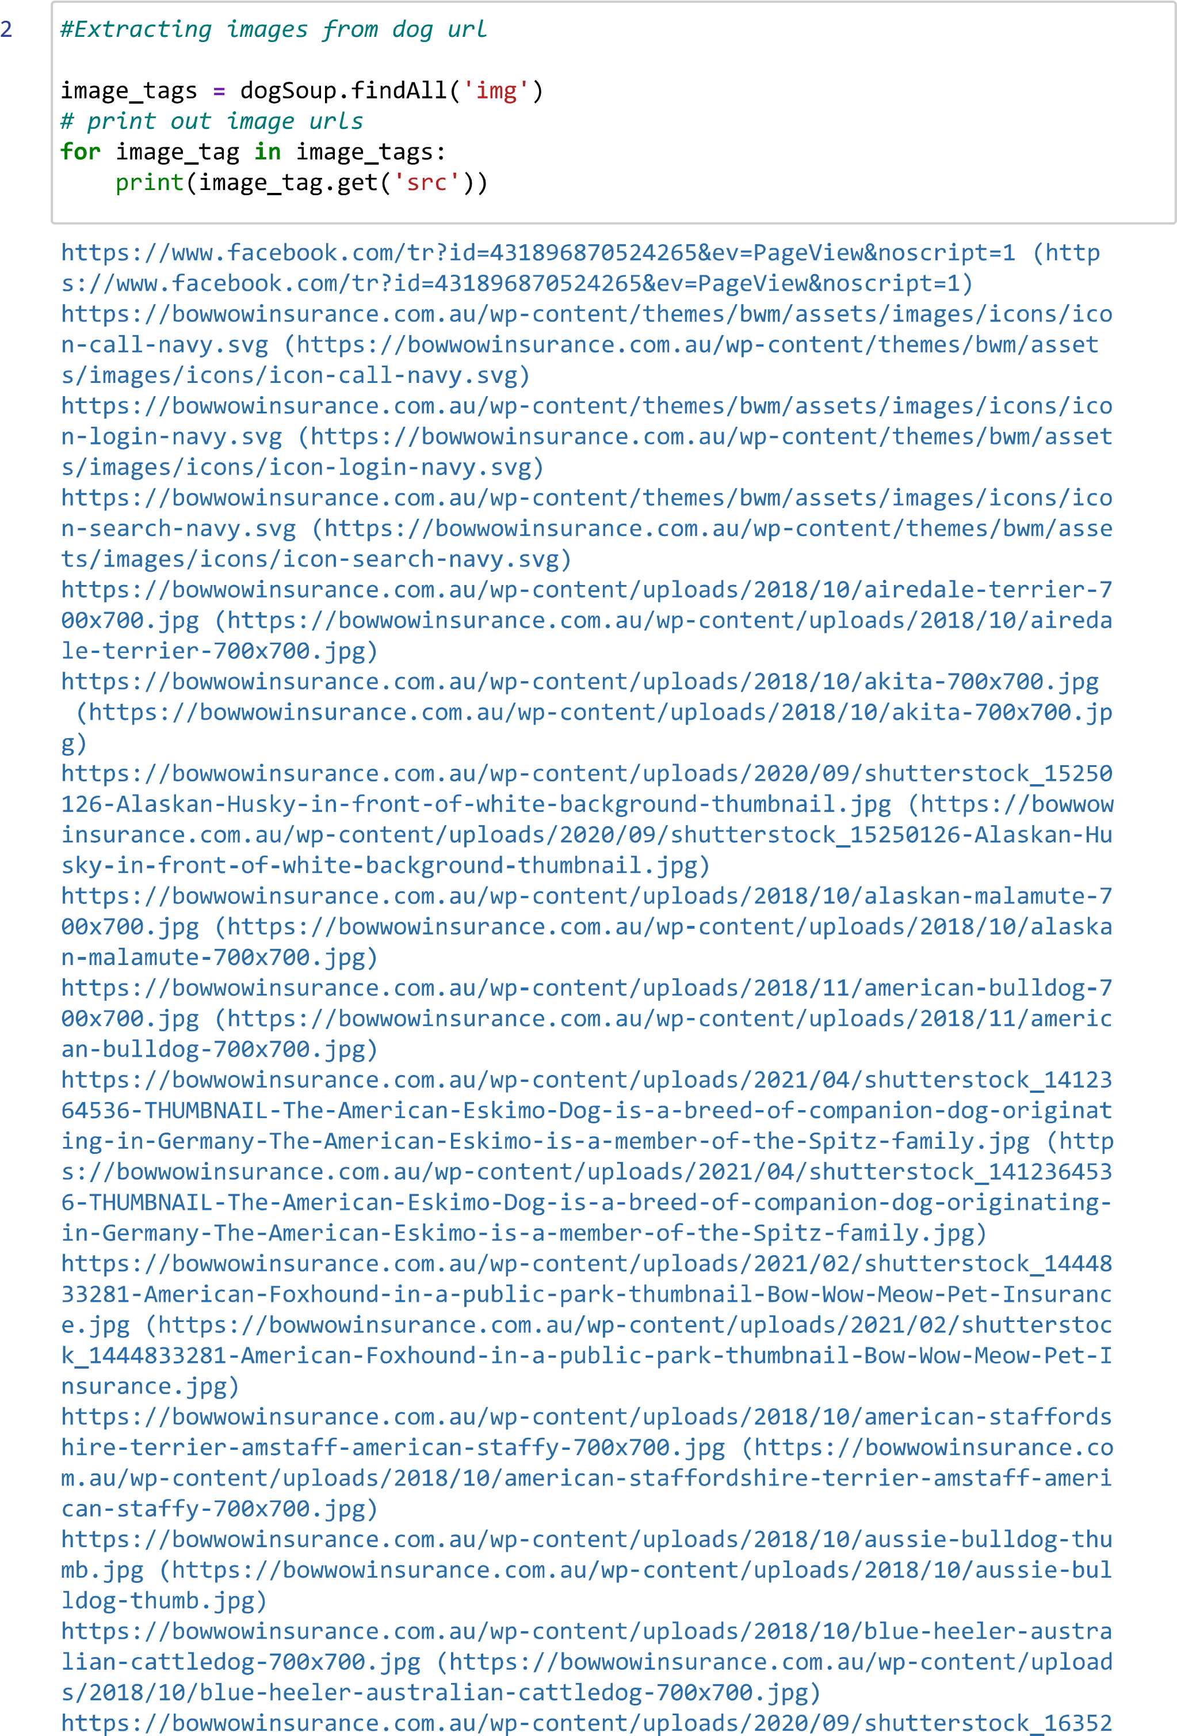

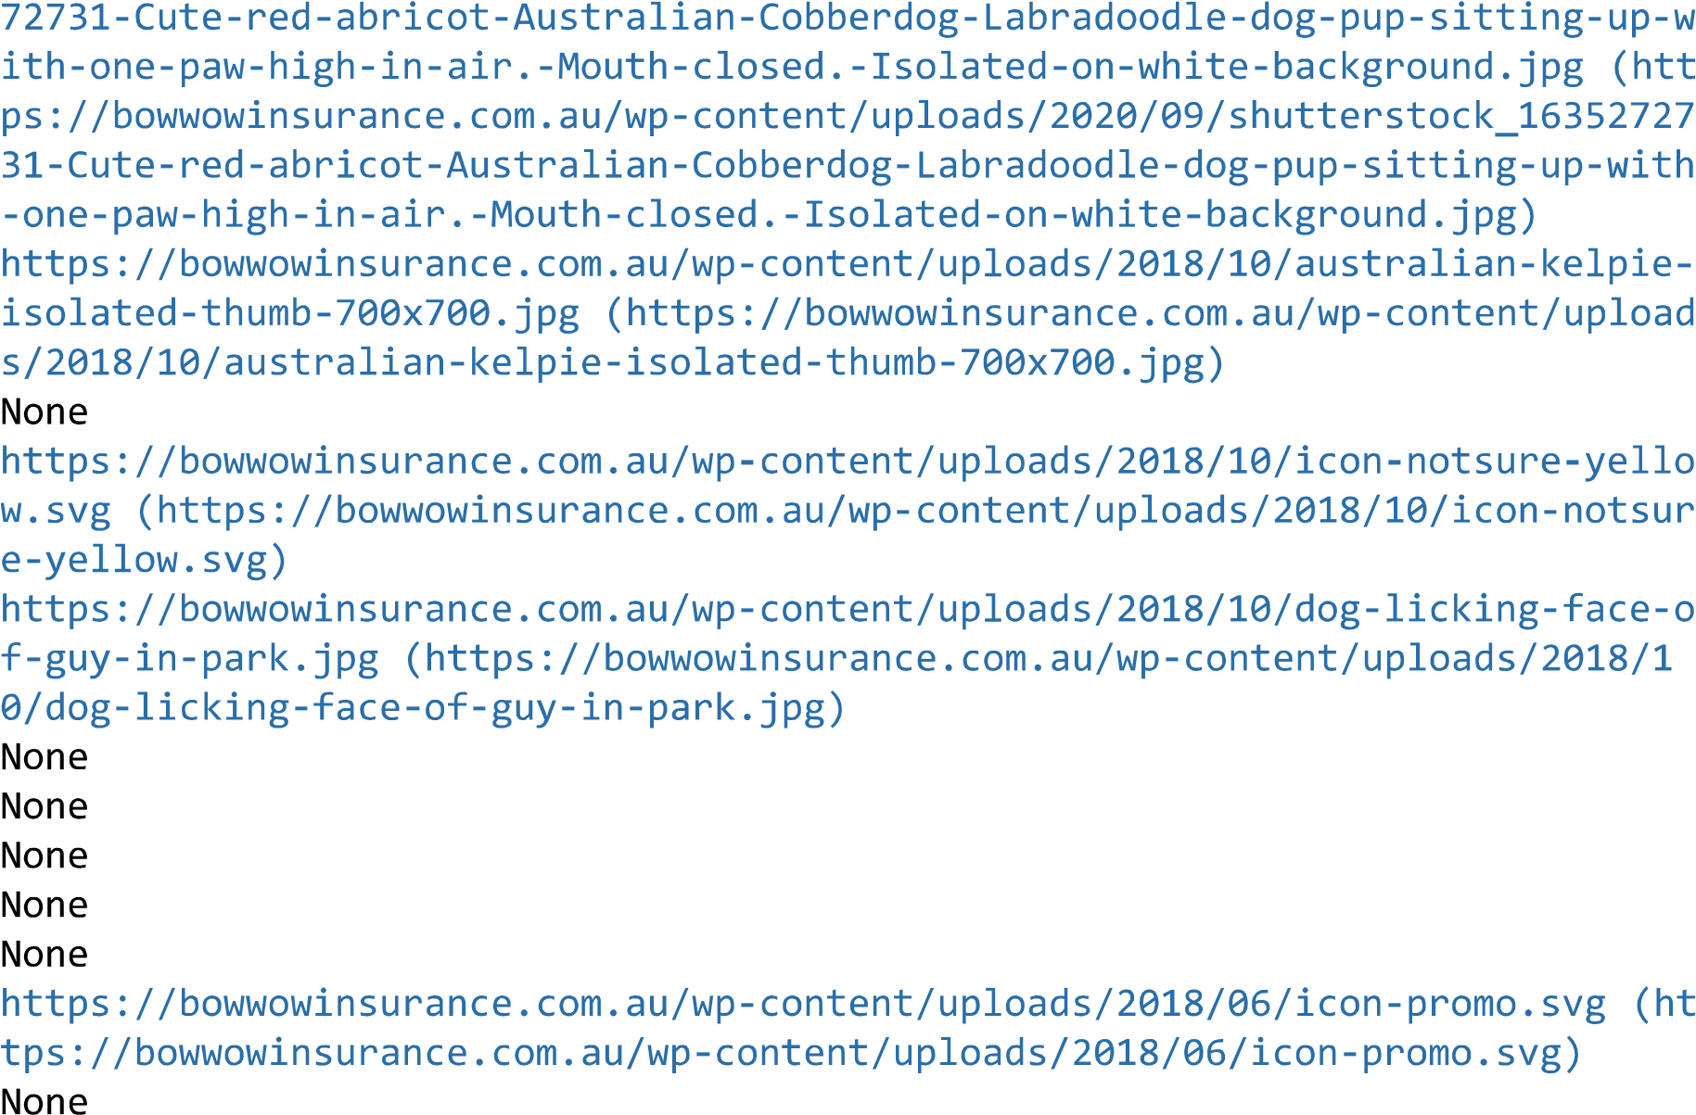

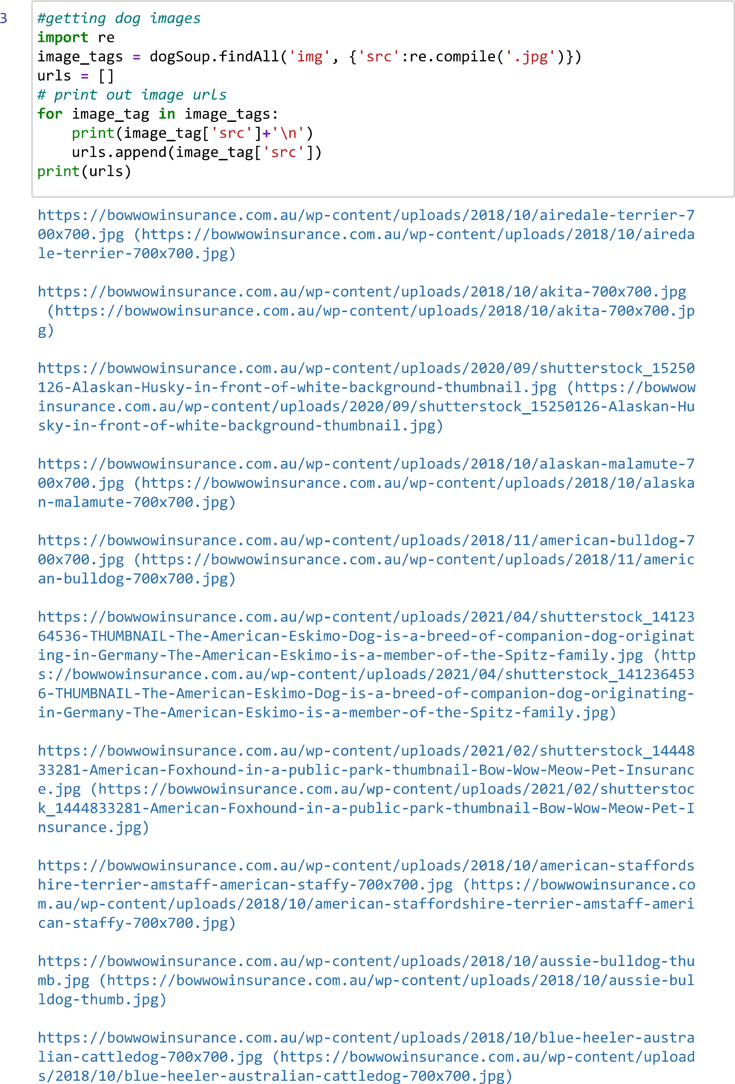

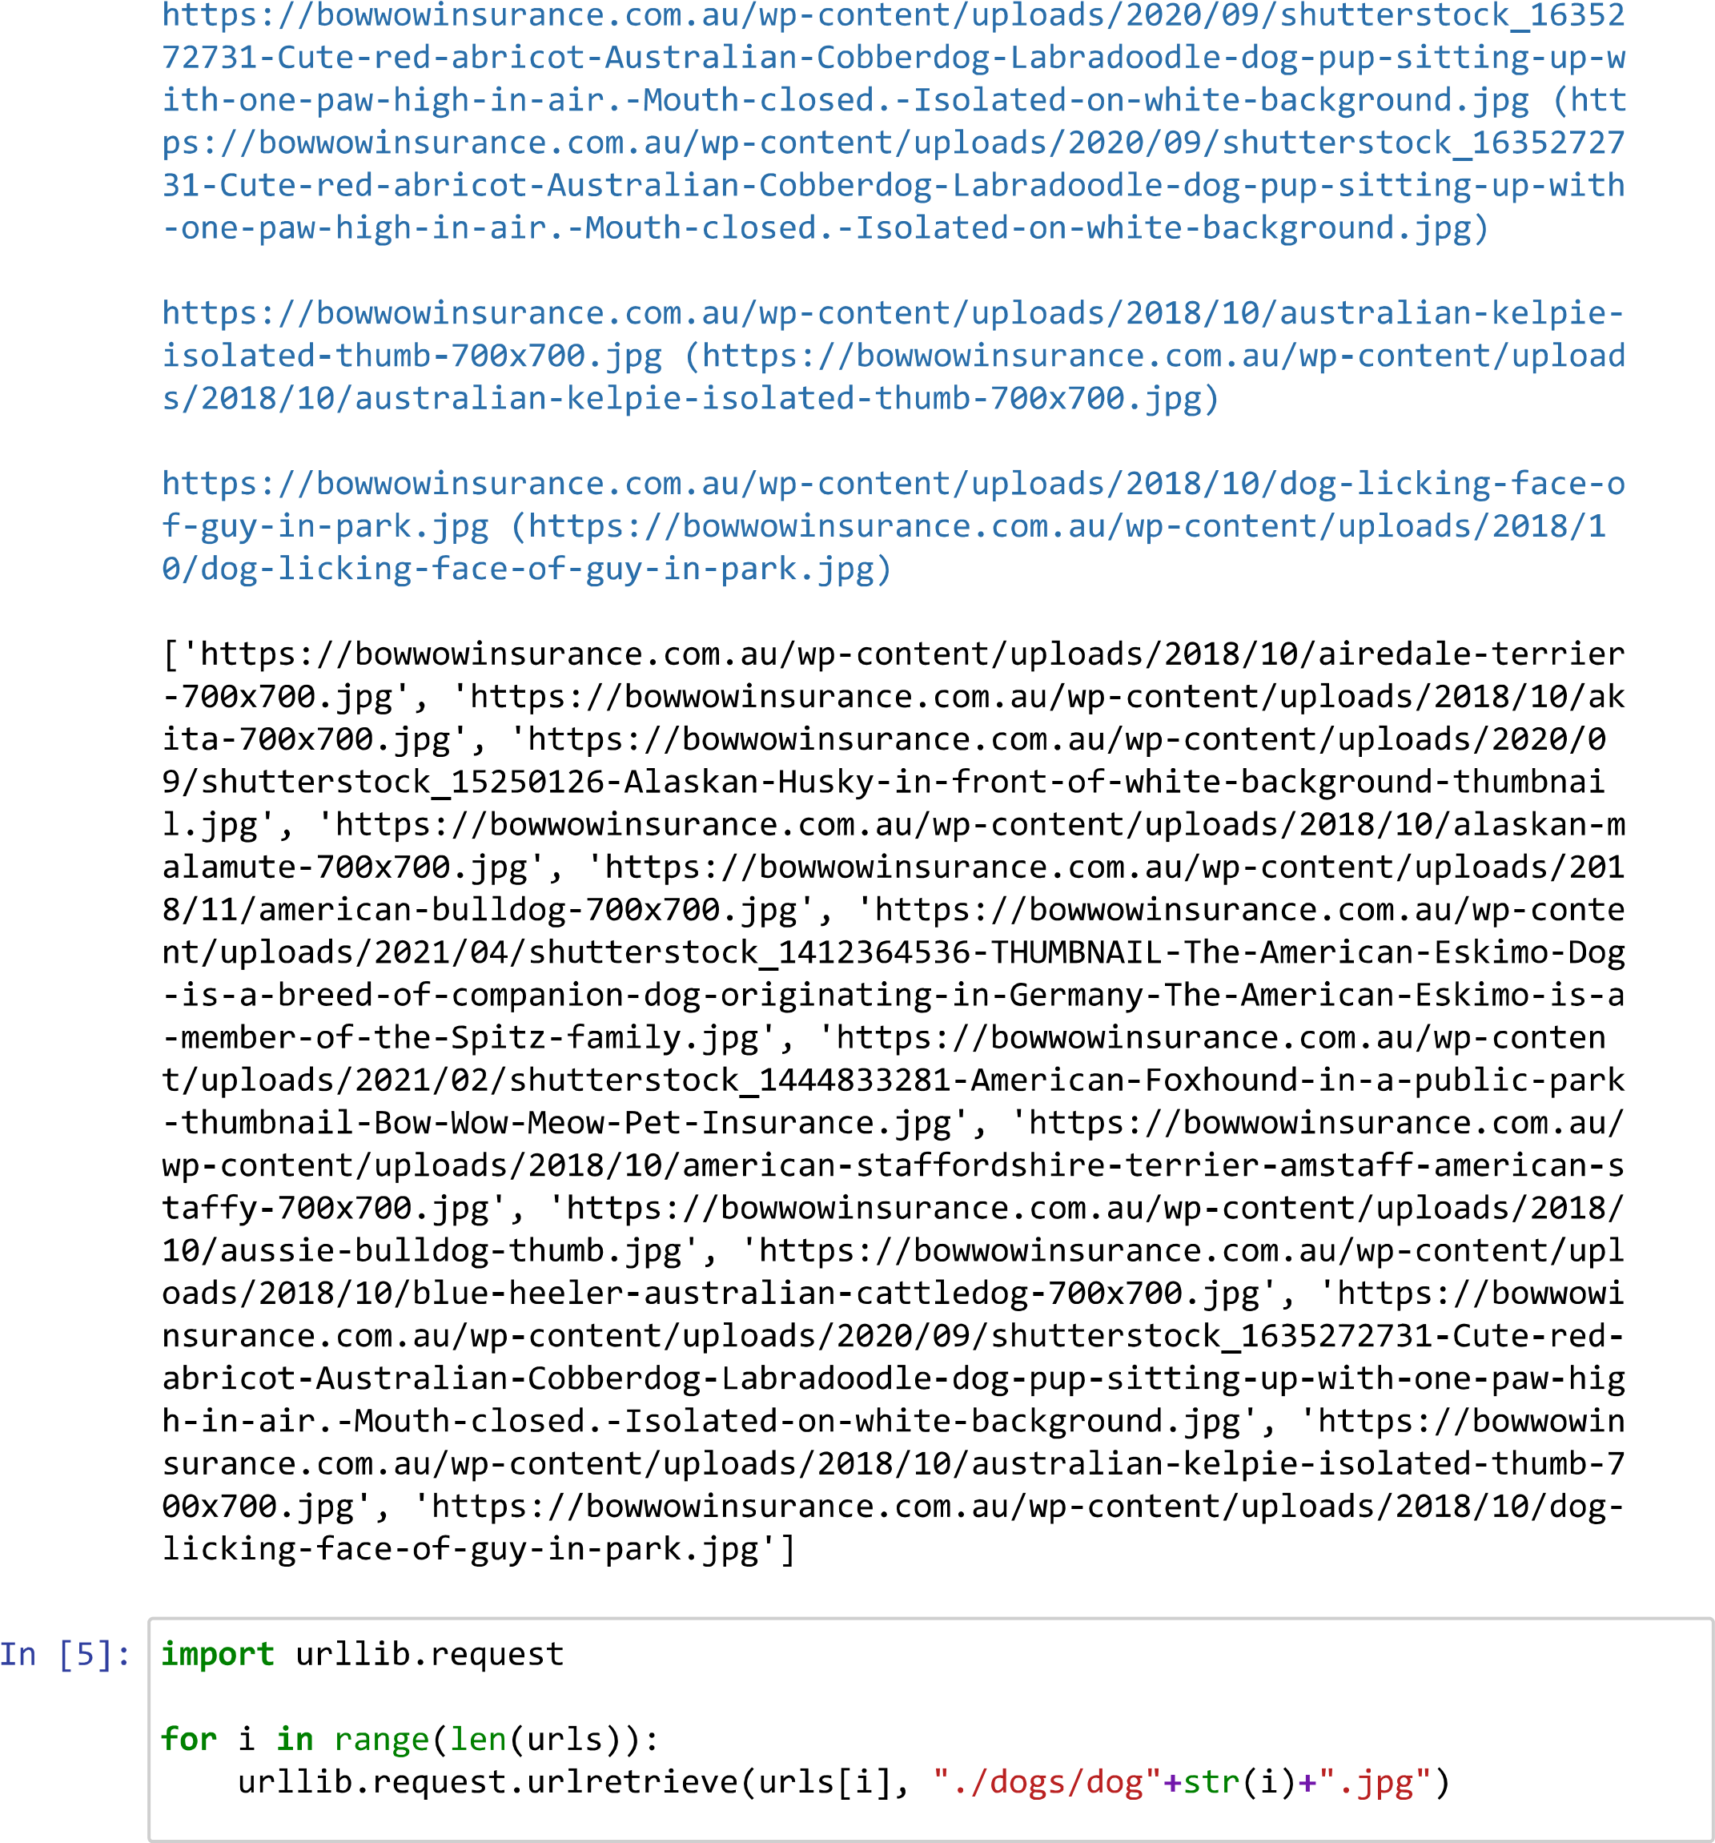

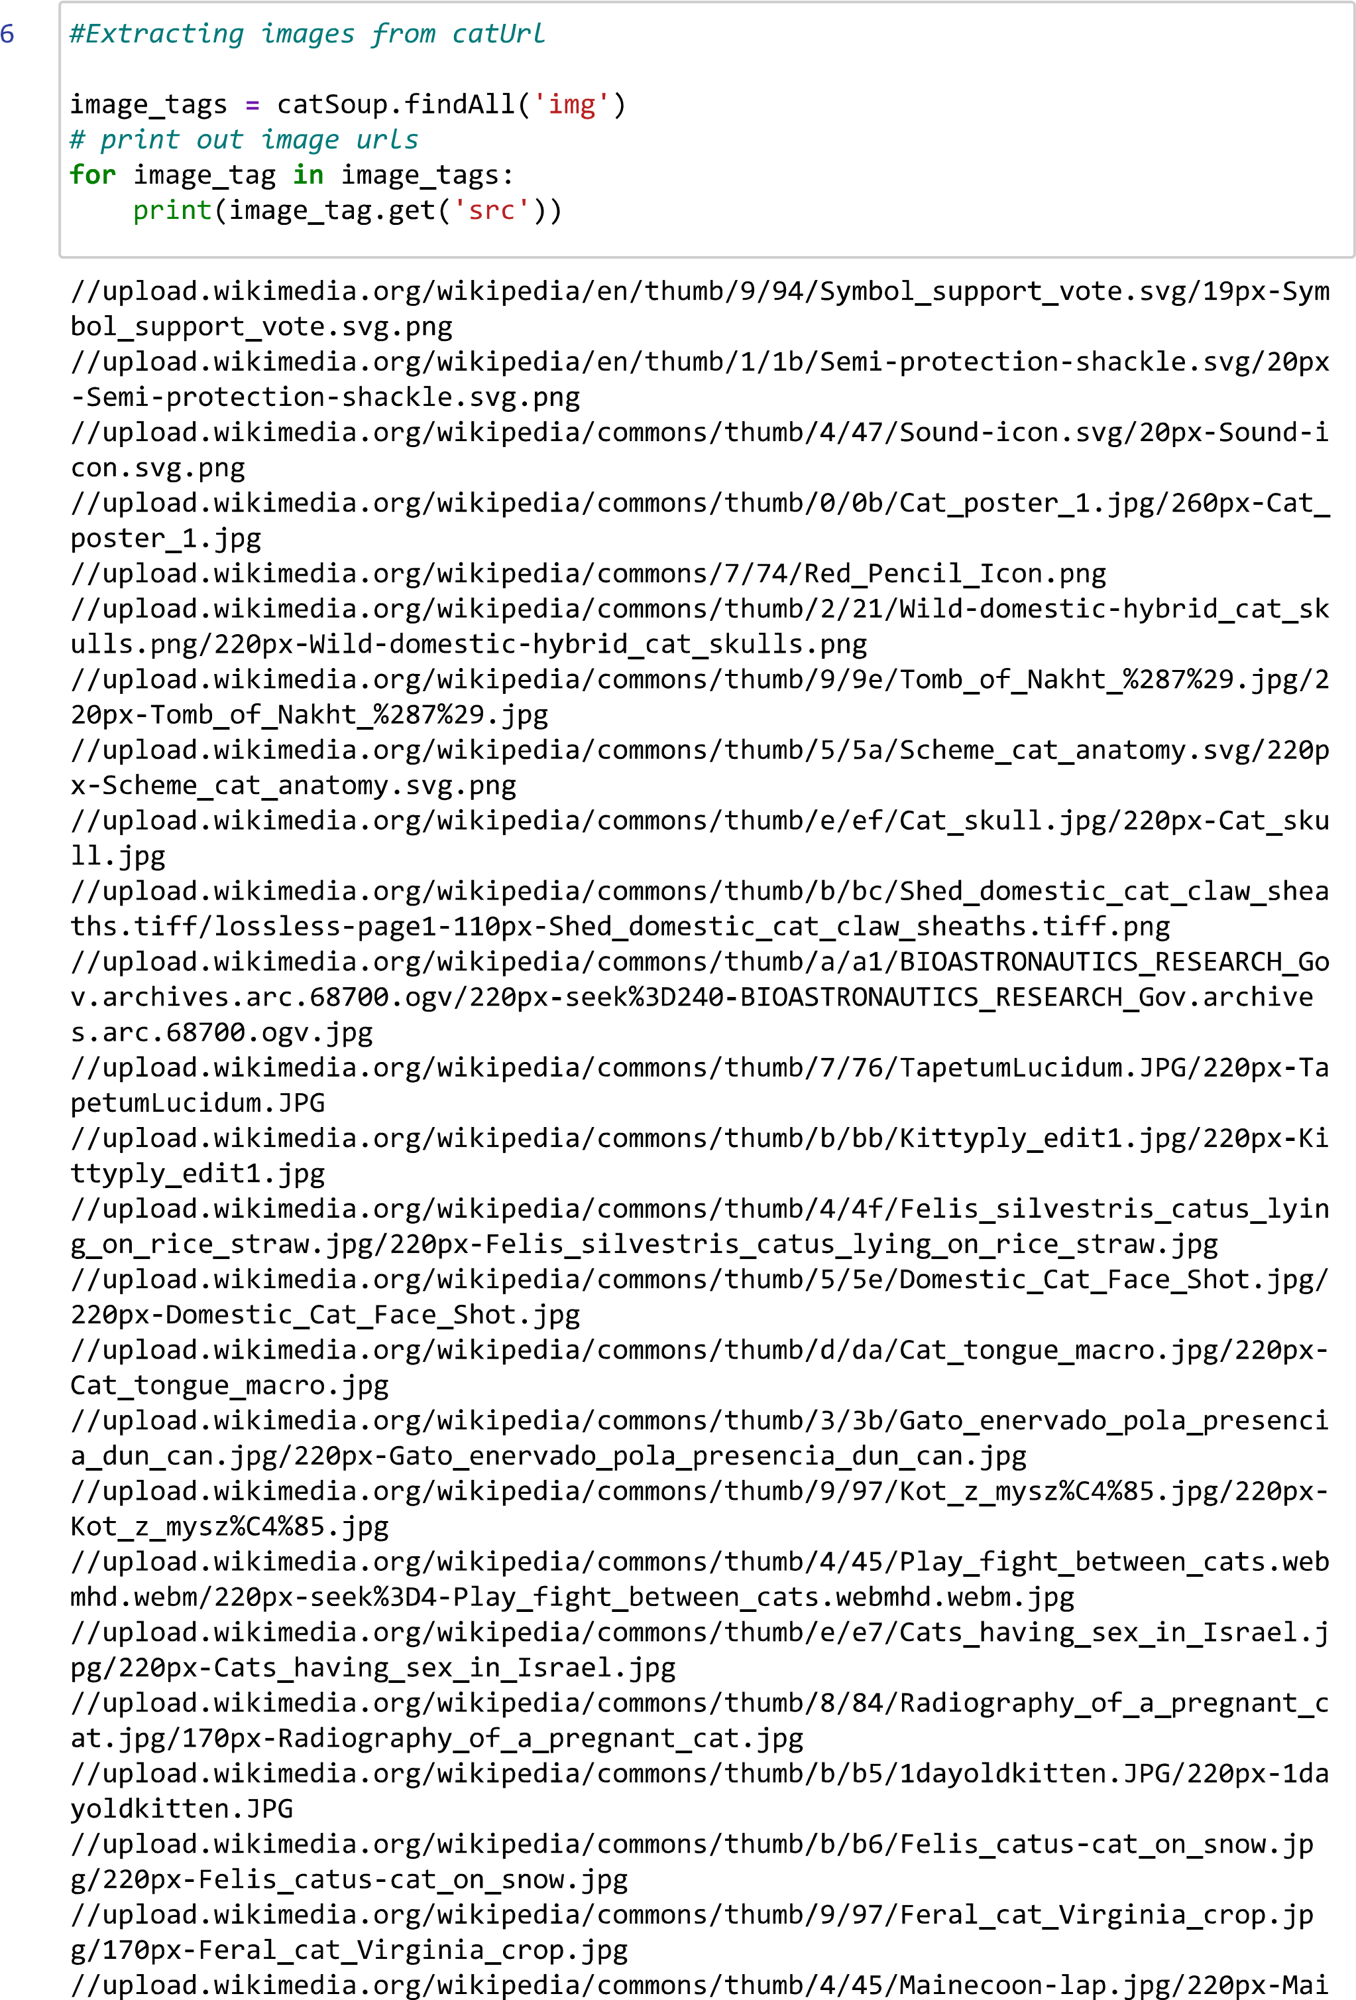

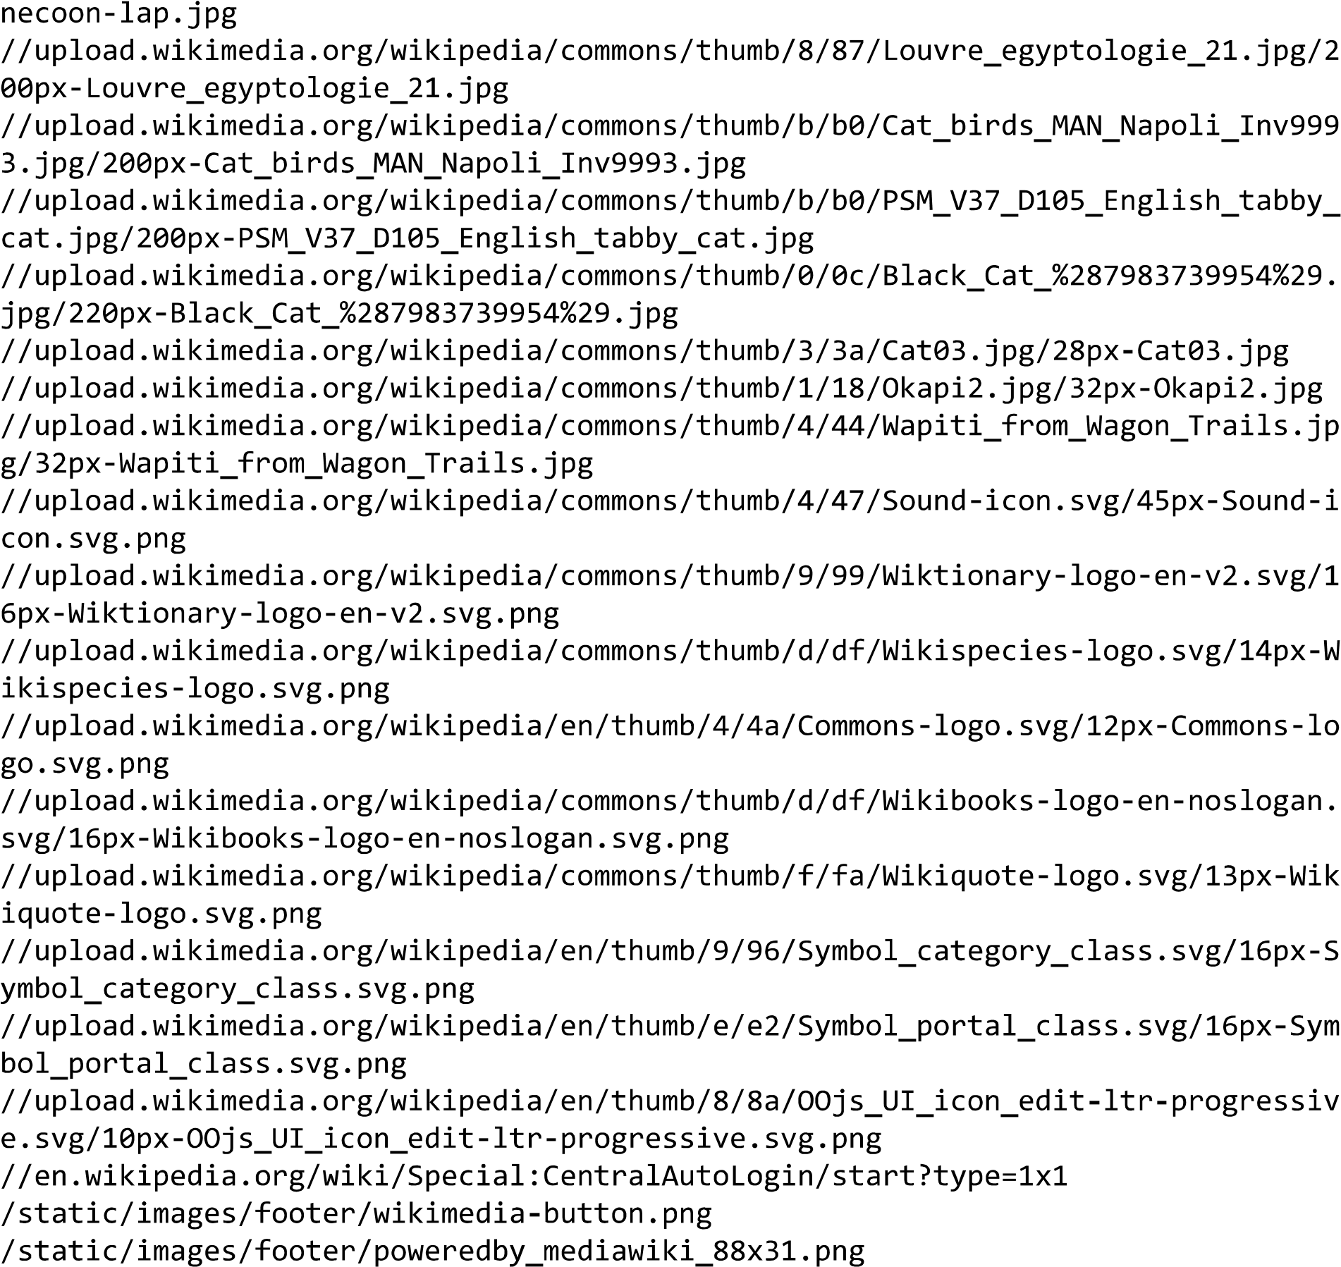

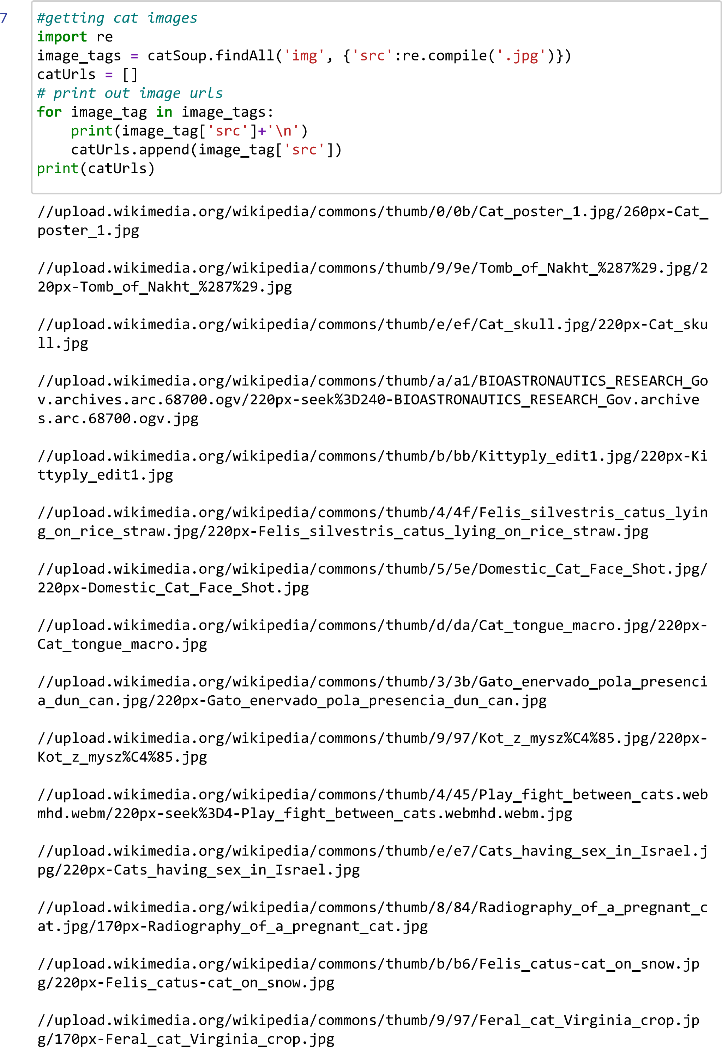

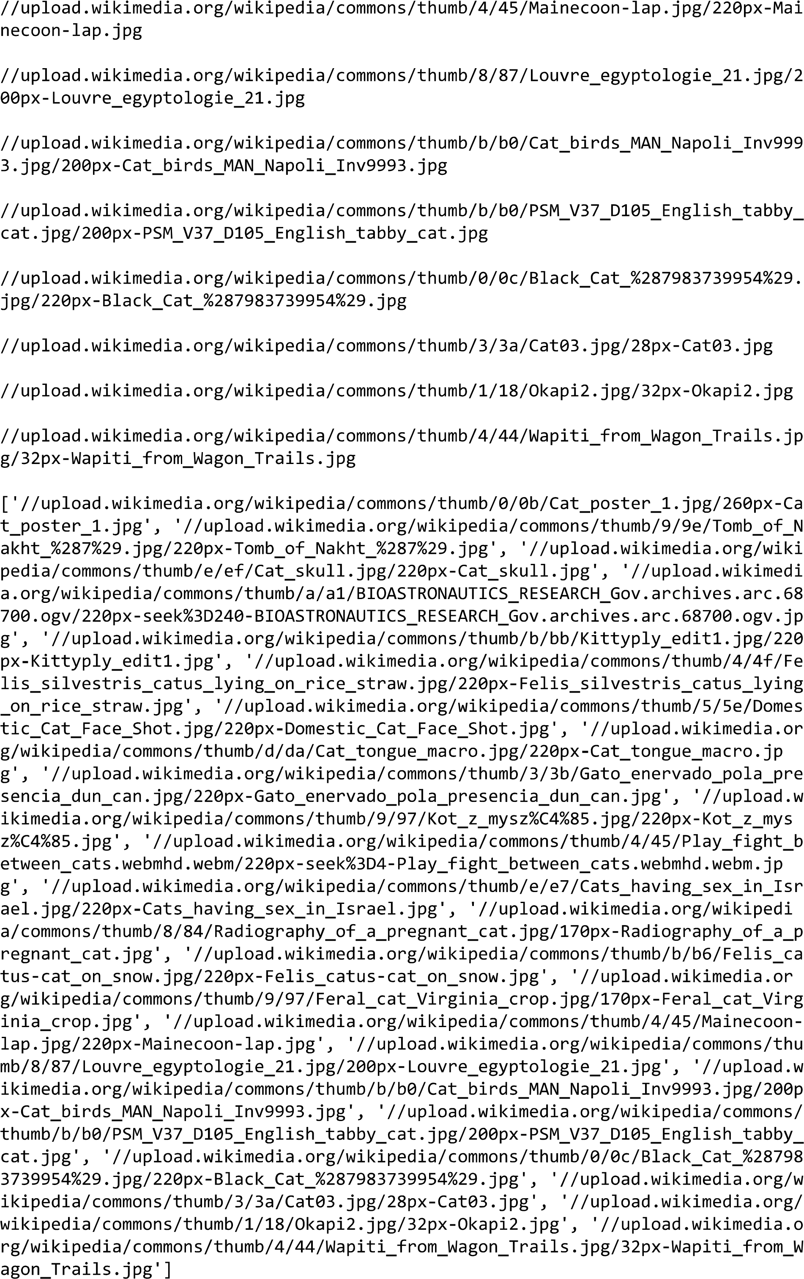

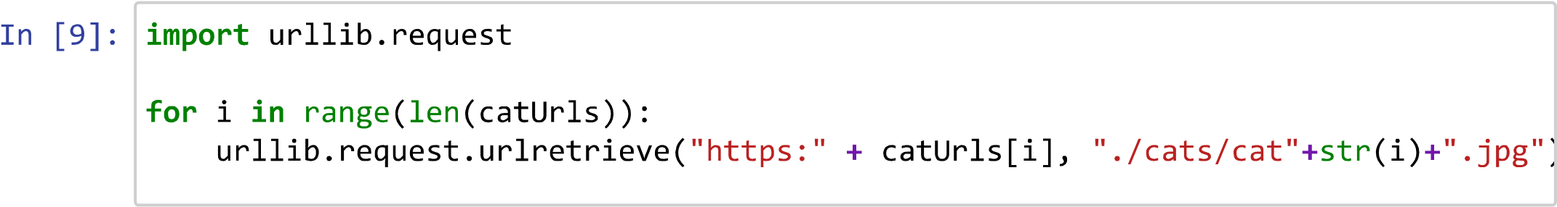

**Dogs folder Created:**

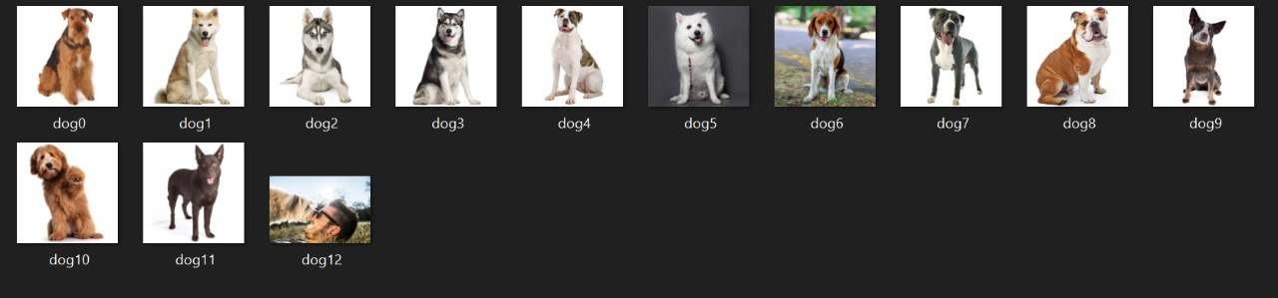

**Cats folder Created:**

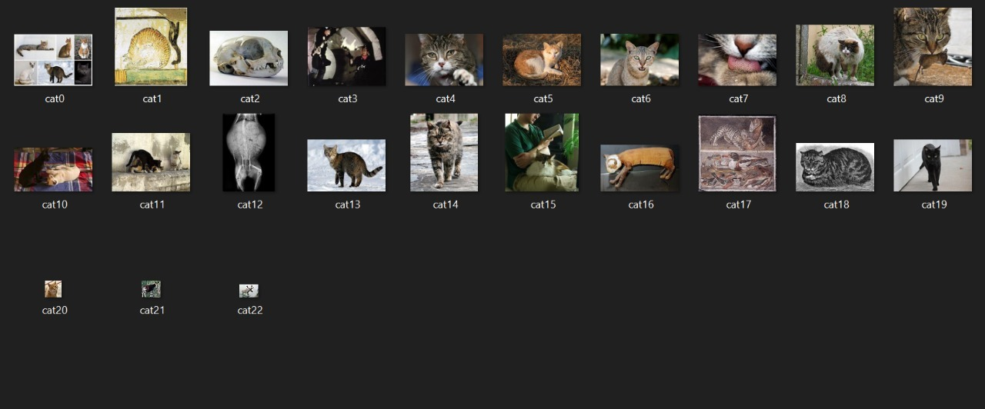

**\*\*\* END \*\*\***